- Test papers must be withdrawn after use and stored securely in the school until Friday 15th June 2018.

RSHS

CHEMISTRY
UNIT 1
2018

MARKING GUIDE

Section One: Multiple-choice (40 marks)

1 | a □ b □ c □ d ■ |  | 11 | a □ b □ c ■ d □
2 | a ■ b □ c □ d □ |  | 12 | a □ b ■ c □ d □
3 | a □ b □ c ■ d □ |  | 13 | a □ b □ c □ d ■
4 | a □ b □ c ■ d □ |  | 14 | a ■ b □ c □ d □
5 | a □ b □ c □ d ■ |  | 15 | a □ b □ c □ d ■

6 | a □ b ■ c □ d □ |  | 16 | a ■ b □ c □ d □
7 | a □ b □ c □ d ■ |  | 17 | a ■ b □ c □ d □
8 | a □ b □ c □ d ■ |  | 18 | a □ b ■ c □ d □ |  |  | (2 marks per question)
9 | a ■ b □ c □ d □ |  | 19 | a □ b □ c ■ d □
10 | a □ b □ c ■ d □ |  | 20 | a □ b ■ c □ d □

Section Two: Short answer 35% (70 marks)

This section has 10 questions. Answer all questions. Write your answers in the spaces provided.

When calculating numerical answers, show your working or reasoning clearly. Express numerical answers to the appropriate number of significant figures and include appropriate units where applicable.

Spare pages are included at the end of this booklet. They can be used for planning your responses and/or as additional space if required to continue an answer.
- Planning: If you use the spare pages for planning, indicate this clearly at the top of the page.
- Continuing an answer: If you need to use the space to continue an answer, indicate in the original answer space where the answer is continued, i.e. give the page number. Fill in the number of the question(s) that you are continuing to answer at the top of the page.

Suggested working time: 60 minutes.

Question 21 (12 marks)

Write ionic equations for any reactions that would occur when the following pairs of solutions are mixed. Write “no reaction” if the pair of solutions would not react. For each of the example write the observations that you would make. Write “no visible reaction” if nothing would be observed on mixing the solutions.

- Sodium sulfate and lead nitrate (4 marks)

Pb²⁺_{(aq)} + SO₄²⁻_{(aq)} →PbSO_{4(s)} | 2 marks if as shown
if PbSO₄ is shown as the precipitate by either an ionic equation without states Or a molecular equation with states | 1 mark
Before observations: Two colourless liquids are mixed | 1 mark:
After observation: a white precipitate is produced | 1 mark:

- Potassium iodide and lead nitrate (4 marks)

Pb²⁺_{(aq)} + 2I⁻_{(aq)} →PbI_{2(s)} | 2 marks if as shown
if PbI₂ is shown as the precipitate by either an ionic equation without states Or a molecular equation with states | 1 mark
Before observations: Two colourless liquids are mixed | 1 mark:
After observation: a yellow precipitate is produced | 1 mark:

- Copper II chloride and silver nitrate (4 marks)

Ag⁺_{(aq)} + Cl⁻_{(aq)} → AgCl_{(s)} | 2 marks if as shown
if AgCl is shown as the precipitate by either an ionic equation without states Or a molecular equation with states | 1 mark
Before observations: A blue and a colourless liquid are mixed | 1 mark:
After observation: a blue solution and a white precipitate form | 1 mark:

Question 22 (8 marks)

Consider the elements labelled A-E on the diagram below, which shows the first four periods of the periodic table.

A
 | B |  |  |  |  |  |  |  |  |  |  |  |  |  | C | D
E

(a) Why are A and E both in group 1? (1 mark)

- both have one valence electron

(b) Why are B, C and D all in period 2? (1 mark)

- all have electrons filling the second shell

(c) Why would atoms of element C and E form chemical bonds? State the type of compound formed and describe how the chemical bonds form. (3 marks)

By losing/gaining electrons both elements would  achieve a full outer shell or  Achieve the lowest energy state | - 1
Ionic | - 1
oppositely charged ions are attracted to each other | - 1

(d) Why would atoms of element C and D form chemical bonds? State the type of compound formed and describe how the chemical bonds form. (3 marks)

By sharing electrons both elements would  achieve a full outer shell or  Achieve the lowest energy state | - 1
covalent | - 1
Positive nuclei are attracted to the shared electrons | - 1

Question 23 (8 marks)

All matter can be classified as either pure substances or mixtures.

(a) Complete the table below by writing the name or formula of the compound, as well as classifying the compound as having consistent properties with either an ionic or covalent substance. (6 marks)

Name | Formula | Covalent or ionic bonding
Ammonium carbonate | (NH₄)₂CO₃ | ionic
Iron(III) nitrate | Fe(NO₃)₃ | ionic
Ethanoic acid | CH₃COOH | covalent

The table above refers only to pure substances.

(b) State two (2) ways a mixture differs from a pure substance. (2 marks)

- mixture has no fixed composition, no formula, variable properties, can more easily be separated, contains 2 or more different substances… any 2 relevant points

Question 24 (7 marks)

Complete the table below, showing the subatomic particle arrangement of the four different species.

Symbol | Number of protons | Number of neutrons | Electron configuration
¹⁹F | 9 | 10 | 2, 7
²³Na⁺ | 11 | 12 | 2, 8
³²S²⁻ | 16 | 16 | 2, 8, 8
¹⁴C | 6 | 8 | 2, 4
Question 25 (7 marks)

Salts containing the metal potassium (K) have a characteristic lilac (purple) colour in a flame test. A chemistry student was planning on performing flame tests on a series of different salt samples, trying to find one that contained a rare isotope of potassium. However, the student decided that the flame test would not be reliable as the isotope flame colour would be different from usual.

(a) What is an isotope? (2 marks)

atoms of an element that have the same number of protons but different numbers of neutrons or  atoms with the same atomic number but different mass number | 2

(b) Was the student correct? Explain. (3 marks)

No | 1
For indicating they understand that the flame colour is dependent on an electron transition | 1
For indicating that there is no change in energy shells with isotopes | 1

The relative atomic mass (Ar) of potassium is 39.10.

(c) What is the Ar of an element? What does it indicate that the Ar of potassium is close to the whole number of 39? (2 marks)

Ar is the average mass of an atom compared to 1/12th the mass of a C-12 or  weighted average mass of all known isotopes of an element | 1
Because of the presence of isotopes | 1

Question 26 (8 marks)

Nanosilver is an example of a nanomaterial and refers to an extremely finely divided form of silver. Nanosilver is used widely due to its ability to function as an antibiotic and disinfectant.

(a) What is a nanomaterial? (1 marks)

- materials containing particles between 1-100 nm in size

Despite its beneficial qualities, there may be potential negative side effects from the use of nanosilver. Some people who have been exposed to high levels of silver, for example in certain medications, have developed a condition where their skin turns blue.

(b) What are the potential risks of using products containing nanomaterials? (2 marks)

not sure of side effects, (unknown risks)  small size can move into cells,  could pose risks to the environment | any 2 relevant points
- …

The properties of nanoparticles differ from those of the bulk in many ways. It is believed that the antibacterial properties of nanosilver occur when silver ions (Ag⁺) are released at the corners of silver crystals. Chemical reactivity is also dependent on surface effects particularly at the edges of crystals. Nano particles of gold may react where bulk gold may be inert. The colour of the nano particles is determined by their size. Small sizes are more efficient at absorbing small wavelengths of light such as blue or green making a solution of the particles appear red. Larger particles absorb longer (red) wavelengths so the solution appears more blue.

- Why is nanosilver so much more effective as an antibiotic than bulk silver.

Ag+ ions are formed at the corners | 1
Nanosilver has many more corners than bulk silver so it produces more ions | 1

- During the formation of nanogold the solution was seen to change from a blue to a red colour.
Does this indicates nanoparticles growing or being reduced in size.

reducing | 2

- Name one property where gold differs in its bulk form to that of its nanoparticles

Colour or reactivity | 1

Question 27 (11 marks)

For each of the following pairs of molecules;

- Circle the one that you would expect to have the highest boiling point, and
- Give a brief explanation for your choice.

(a) hydrogen fluoride OR hydrogen chloride (2 marks)

HF has hydrogen bonding (1)

(b) carbon dioxide OR sulfur dioxide (3 marks)

Carbon dioxide has only dispersion forces as it is linear | 1
SO₂ has dipole forces as well which are stronger | 1

(c) bromine OR iodine (3 marks)

Both have only dispersion forces | 1
I₂ is the larger molecule so will have stronger forces | 1

- CH₃OH or CH₂O (3 marks)

CH₂O has dipole forces/ is polar | 1
CH₃OH is capable of H bonding which is stronger | 1

Question 28 [7 marks]
- Write the electronic configuration of a sodium atom and a magnesium atom. (2 mark)

Sodium 2,8,1 Magnesium 2,8,2 1 each

The first five ionisation energies of sodium and magnesium in MJ mol⁻¹ are shown below:
Ionisation | 1st | 2nd | 3rd | 4th | 5th
Sodium | 0.502 | 4.569 | 6.919 | 9.550 | 13.356
Magnesium | 0.744 | 1.457 | 7.739 | 10.547 | 13.636

- Account for the difference in the 1st ionisation energies of sodium and magnesium? (2 marks)

The first IE of Mg is higher than that of Na | 1
Because an electron is being removed from a nucleus with a greater positive charge | 1

- Account for the difference in the 2nd ionisation energies of sodium and magnesium? (2 marks)

Second ionisation of Na removes an electron from the second shell | 1
Second IE of Mg is still only removing electron from third shell | 1

- Explain the progressive increase in ionisation energy of the sodium as we go from 1st to 5th ionisation. (1 mark)
Electrons are being removed from increasingly positive atoms/ions

End of Section Two
Section Three: Extended answer 40% (80 marks)

This section contains five (5) questions. You must answer all questions. Write your answers in the spaces provided below.

Where questions require an explanation and/or description, marks are awarded for the relevant chemical content and also for coherence and clarity of expression. Lists or dot points are unlikely to gain full marks.

Final answers to calculations should be expressed to the appropriate number of significant figures.

Spare pages are included at the end of this booklet. They can be used for planning your responses and/or as additional space if required to continue an answer.
- Planning: If you use the spare pages for planning, indicate this clearly at the top of the page.
- Continuing an answer: If you need to use the space to continue an answer, indicate in the original answer space where the answer is continued, i.e. give the page number. Fill in the number of the question(s) that you are continuing to answer at the top of the page.

Suggested working time: 70 minutes.

Question 29 (14 marks)

Study the following diagram of a torch (flashlight). Several components have been labelled and some information about the properties of these materials has also been included.

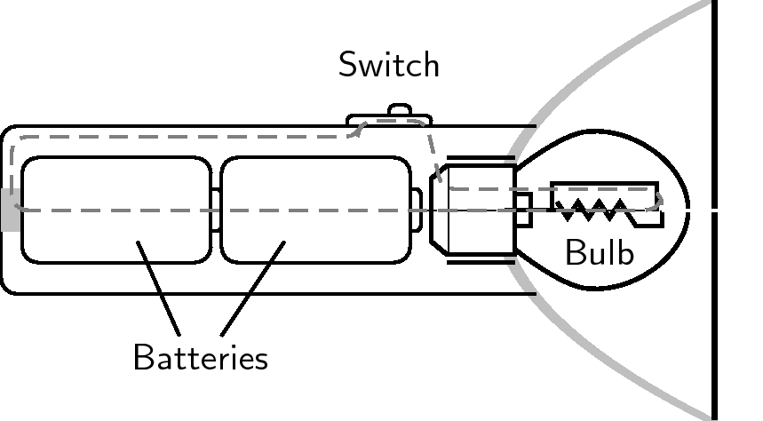
Ammonium chloride (NH₄Cl) paste
- used as a component in batteries because it conducts electricity.
Glass / Silicon dioxide (SiO₂)
- used to protect the bulb because it is hard and strong.
Plastic ((C₂H₄)_{x})
- used to make the body of the torch because it is a soft, easily shaped substance that is an electrical insulator.
Copper (Cu)
- used for the wiring because it is malleable and conducts electricity.

Explain why each of the labelled materials has been used in this torch. Your answer should focus on the type of bonding present in each of the four (4) labelled components, as well as an explanation of their main properties (shown in bold), in terms of the structure and bonding present.

Plastic is a covalent molecular substance | - 1
- Weak forces between particles are easily disrupted making the material soft and easily shaped. | - 0-2
- It is non conducting because there are no free electrons or ions in the molecules | - 1
SiO₂ is a covalent network | - 1
- strong covalent bonding throughout entire 3D network  - a large amount of force is required to disrupt to disrupt the covalent bonds, therefore hard and strong | - 1-2
Cu has metallic bonding | - 1
- The delocalised electrons move freely within an array of positive ions allowing electricity to be conducted | - 1
- They are the charge carriers allowing conduction | - 1
- Positive ions are able to be moved while maintaining an attraction to delocalised electrons hence it is malleable | - 1
NH₄Cl is an ionic substance | - 1
When mixed with water the ions dissociate from each other  These ions are mobile and able to conduct charge | - 1-2

Question 30 (14 marks)

Meteorites that hit the Earth’s surface can provide scientists with information about the chemical composition of objects in different parts of our solar system or galaxy. A sample of ice was taken from a meteorite that landed in the Australian outback, and the extra-terrestrial water was analysed to determine the presence of various elements.

Atomic absorption spectroscopy (AAS) was used to determine the presence and concentration of various elements in the extra-terrestrial water, including silicon. AAS is an effective technique because each element has it’s own characteristic absorption / emission spectrum.

(a) Explain how electron absorption / emission spectra are related to the electron shells (levels) of an element. (4 marks)

Each element has its own unique energy levels/ electron shells have specific energies | 1
Electrons absorb/release the exact amount of energy to move between energy levels | 1
This energy corresponds to a particular colour that is absorbed / released by the substance | 1
Correctly relates the movement of electrons to the type of spectra formed eg  absorption is caused by an electron moving to a higher energy shell | 1

AAS determined that there was some silicon present in the extra-terrestrial water. Some of the silicon sample was isolated and sent for analysis by mass spectrometry, to determine if the isotopic forms of this silicon were the same as those found on Earth.
The results of the mass spectrometry are shown below.

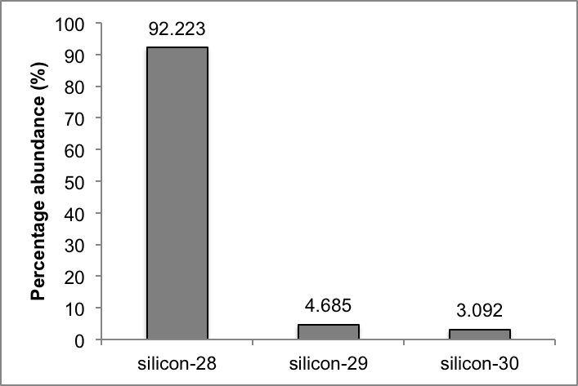
(b) Calculate the relative atomic mass (Ar) of this extra-terrestrial silicon, and comment on its similarity to the silicon found on Earth. (3 marks)

Ar = ( 92.223 x 28 + 4.685 x 29 + 3.092 x 30 ) / 100 | 1
28.109 | 1
Slightly higher than Earth silicon (28.09) | 1

A portion of the periodic table, showing the elements surrounding silicon, is given below. Consider the five elements in the diagram.

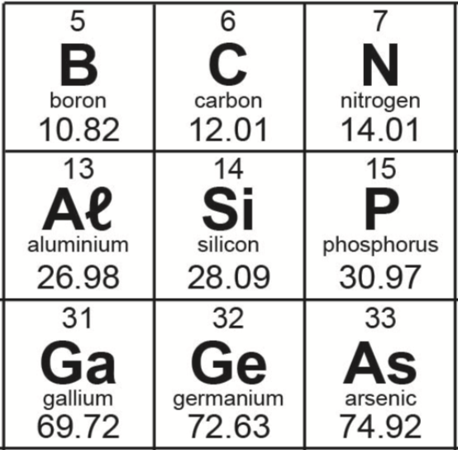

(c) Of these elements, germanium has the largest atomic radius and the smallest first ionisation energy. Explain why. (3 marks)

Ge has largest atomic radius because greatest number of electron shells filled | 1
outermost electron is furthest from nucleus or allow shielding of inner shells | 1
Means less energy is required to remove the electron | 1

(d) Define electronegativity, and state and explain the trend in electronegativity as you move left to right from aluminium to phosphorus. (4 marks)

electronegativity is measure of how strongly an atom attracts a bonding pair of electrons towards itself | 1
electronegativity increases from aluminium to phosphorus (i.e. across a period) | 1
this is because across a period the atomic radius decreases | 1
and the nuclear charge increases | 1

Question 31 (17 marks)

This question is about the properties of water

(a) In cold climates, bodies of water such as ponds and lakes can freeze. The ice floats on the top of water because it is less dense than the liquid water. This allows the aquatic life in the water to survive during the colder months.

Describe, using a diagram, intermolecular bonding in solid ice and explain why the volume of the water increases (and the density reduces) when it changes from liquid water to solid ice. (5 marks)

Diagram showing O end of water aligning with the H end of other molecules | 1
The H bonding in water forms and reforms as molecules move in the liquid phase. | 1
This random arrangement of molecules in water occupies less space | 1
As water cools the H bonding causes the molecules to align | 1
This occupies more volume than the random arrangement found in water

Allow some discretion in the allocation of marks especially the second mark

(b) Many insects and spiders are able to walk on the surface of water but they are unable to walk on the surface of volatile liquids such as acetone (CH₃COCH₃) and petrol (C₈H₁₀).
i) Use a suitable diagram to show how the intermolecular forces present allow this to occur in water but not the other liquids. (6 marks)

Diagram showing more bonds inwards near the surface of the water | 1
The surface tension of water is due to the presence of H bonding | 1
The strength of these bonds gives water its significant surface tension | 1
Petrol and acetone are volatile due to their weaker intermolecular forces | 1
Naming types of forces – petrol dispersion, acetone dipole dipole  OR may talk about dissimilar forces of attraction on insects legs as they are not wet by water | 1
Weaker IMF means less surface tension | 1

ii) If salt was added to the water explain whether this would increase or decrease the insects ability to walk on water. (2 marks)

Salt would increase the intermolecular forces within water | 1
Raising the surface tension | 1

(c) Water is the most commonly used solvent, but it cannot dissolve non polar hydrocarbons such as oil, petrol and grease.

Explain, using your knowledge of intermolecular bonding why water is unable to dissolve these types of substances.
(4 marks)

These hydrocarbons have predominantly dispersion forces | 1
Water is a small polar molecule and has very little low dispersion forces | 1
The attractive forces between water and the hydrocarbon is less than the attractive forces between the hydrocarbon and itself so it tends to not dissolve in water | 1-2

Question 32 [16 marks]
Complete the following table showing the Lewis structure (electron dot diagram), shape, name the shape and show the molecular polarity if any for the four species listed.
Cl₂CO | F₂CH₂ | Ammonia | SO₂
Lewis structure | Lewis structure | Lewis structure | Lewis structure
Lewis diagram may use lines or dots
Atoms must have appropriate number of electrons
No carry through marks

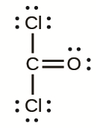 | 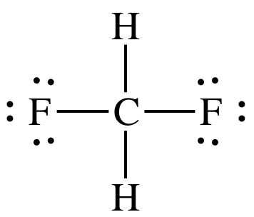 | 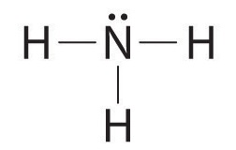 | 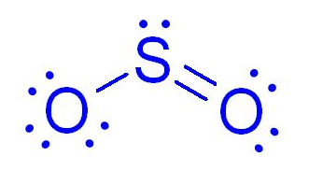
Sketch shape | Sketch shape | Sketch shape | Sketch shape
Students must make a reasonable attempt at drawing the shapes indicated below
Triangular planar | Tetrahedral | Pyramidal | bent
Polarity  Yes | Polarity  Yes | Polarity  Yes | Polarity  yes

Question 33 (11 marks)
Detector response (pA)
Methanamine (CH₃NH₂)
Propane
Dimethyl ether
Ethane
Methane
0.0
0.4
0.8
1.2
1.6
2.0
2.4
2.8
3.2
3.6
Time (minutes)
1000
2000
3000
4000
5000
Helium
Dimethyl ketone

Above is the detector read-out from a high performance gas chromatography apparatus analysing
the organic residues inside a chemical reaction tank using a polar stationary phase in the column.
The mobile phase used was helium, which had a column retention time of 0.6 minutes, as seen from the graph.

(a) Which compound in the tank was present in the greatest concentration? (1 mark)
Propane

The Retention Factor can be calculated by comparing the Retention Time of a substance to the Retention Time of the mobile phase, in this case Helium, using the formula below;

R_{f} = T_{He}
T_{x}

(b) Which compound had a Retention Factor of 0.34? Show calculations. (3 marks)
Dimethyl ether | 1
T_{He} = about 0.6
Tx = 0.34 x 0.6 = about 1.7 closest to DME | 1-2

(c) Which compound being tested is the least polar? Explain. (3 marks)
methane | 1
Since the stationary phase is polar, the least polar will spend the least time dissolving in it and move through in the shortest time or other similar rationale | 1 -2

(d) By considering the bonding types, explain why the Retention Time for methanamine (CH₃NH₂) would be the greatest. (2 marks)

Methanamine would have hydrogen bonding | 1
So it would strongly interact with the polar stationary phase | 1

(e) There are several different types of chromatography each with their own advantages and disadvantages. Give an example of a situation where gas chromatography would not be a suitable but High Performance Liquid Chromatography may work. (2 marks)

The substance being analysed may decompose before it forms a gas so GC would not work | 1
HPLC could allow the analysis of solutions of the substances | 1

End of questions

